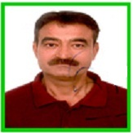

**With Profound grief we regret the Sad and Untimely Demise of our Comrade and Beloved brother,**

**“Shri Rakesh Chander Sundriyal”**

**(24.06.1958 – 14.06.2016)**

**Cremation at Nigam Bodh Ghat on 12.30 PM, Today (15.06.2016)**

**Bereaved N. G. S. U. Family**

**PRAMOD SAWANT, +91-9869166100**

**A.S. TRIPATHI, +91- 9899070592**

**RAJU BHARGAV, +91- 9810028431**

**SATPAL, +91- 9811432843**