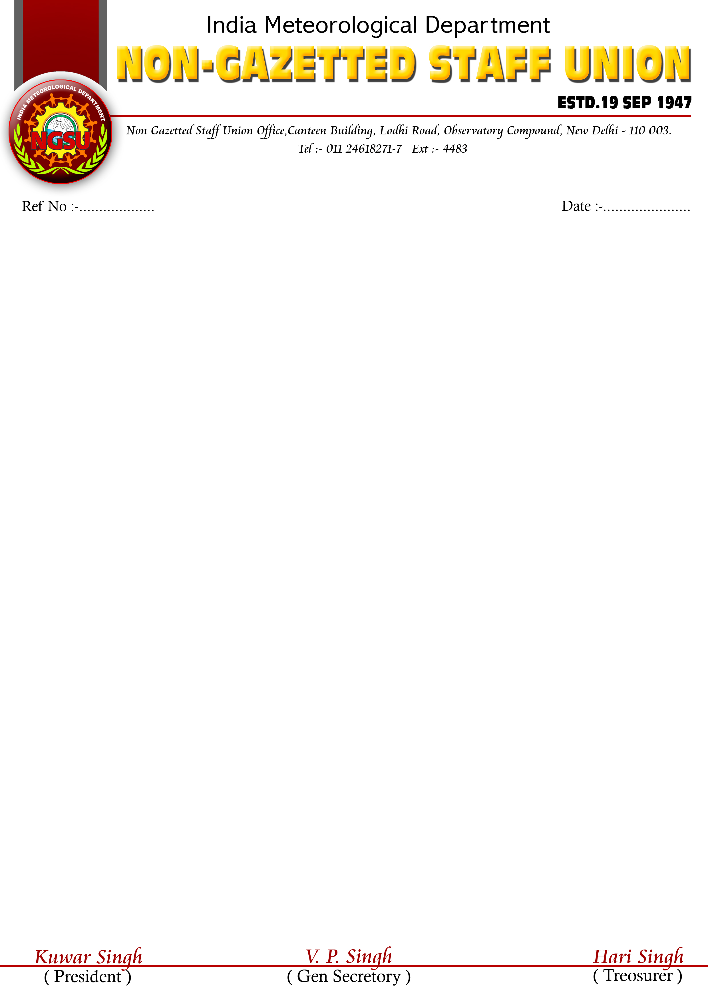
Dear comrades,
Minutes of the meeting held with 7th CPC on 27.04.2015
NGSU has the privilege to inform its members regarding the points discussed and clarified issues with 7th CPC members (along with our PPT as uploaded in the NGSU web site) on 27.04.2015 at 1500 hours IST at the 7th CPC office, New Delhi.
The proceedings and the discussions with the 7th CPC members was as follows:-
- The meeting started at 1500 hours sharp. NGSU members started the presentation slide by slide and explained the overall department’s work arena, its responsibilities towards national and international requirements. The global policies made by WMO and its implementation by the member nations, India being one amongst them
- NGSU also explained the requirement for formation of this ministry (MOES) its aims and objectives. We gave a brief note on the departmental structure.
- Up-gradation of scale
A SA Cadre: GP 4200 to 4600 along with justification for the demand
B Mechanic Cadre : implementation of restructure report at the earliest
C MTS : formation of promotion policy and its implementation and up-gradation of scale from 1800 to 2000 due to the hazardous and technical nature of duties.
- Special status to the department: IMD is amongst few such departments wherein the roster performed and the recruitments rules do not match each other. Hence at every point when the extra duty allowance file is moved to respective ministries it gets rejected. This union brought this matter to the notice of the Pay commission and requested for a special status to the department so that the rules such as ‘ ban on recruitment’ and other limitations should not made applicable. This union also discussed that the data generated by the group B and C staff and officers is scientific, the qualification is scientific the name of the post is scientific but the post is not declared as scientific is a very surprising factor. Moreover only the group A post are scientific and others are central civil services is also a matter of concern. We made it evident that, the data generated by us is not considered scientific but the research made by using the same is declared scientific. To add to this the IMD is only agency which records, validates and archives the meteorological data which is used by agencies such as IITM, NCMWRF and IIT for their study purpose including the officers of IMD.
- Extra duty allowance and night duty allowance: the staff and officers of IMD are posted in the length and breadth of the country. They are working round the clock and are responsible for meteorological data generation in a continuous process. Their work is very essential and hence the seat cannot be kept vacant. In view of these extra duties, closed holiday duties and night duties are part and parcel of the mandate. Hence, we requested for a special scheme may be recommended for the departments having a similar kind of work scenario. We also requested that the scale ceiling should be removed for this department and all the posts working round the clock should be permitted to avail the extra duty allowance instead of compensatory off. We submitted the overtime allowance and the 6th CPC’s recommendations and Govt. approvals but still it was implemented in our department due to contradiction of rules. We also submitted the CAT Jodhpur verdict on night weigtage fought by civilian defense employees that the implementation order issued by ministry of defense but still this order was not generalized by DOP&T and our staff are performing all the duties without any financial/monetary benefits.
- Special allowance for airport staff and cash incentive for working during disastrous weather events such as cyclones: the airport staff are under continuous pressure and their post involves the maximum risk too. Secondly the staff posted in the east and west coast of India are subjected to cyclones and occurrences disastrous weather vents. Under these conditions , all other departments are inside the houses but our people are on field recording the observations and transmitting on real time basis to HQ for weather warnings and for disaster management.
- Non linearity of pay scales: this union expressed that the 6th CPC has not given linear increase of the scale and the lower cadre gets just Rs 100 to 200 after waiting for 10 years in MACP. The promotional avenues are so meager and the stagnation is so high that maximum people got only MACP which too is very low. Hence this non linearity issue should be addressed.
- Demerits of grade pay system: due to Grade pay systems the posts with same grade pay were merged which depleted the existing promotional avenues too. Therefore pay scale system is more beneficial that grade pay system and a minimum of 5 promotions or 5 MACP to the next promotional grade may be considered in a service span.
- Few financial issues were also raised: we expressed that our staff are mostly posted at remote stations where medical facility is not available and hence medical insurance, immediate approvals and deployment of contingent staff on need and also settlement of official tour bills should be prioritized,
- Issues to be addressed by this pay commission: we presented issues that we expect this pay commission to address related to IMD and its working conditions immediately.
- Consolidated demands’: finally we gave a complete list of our demands.
- Vote of thanks: we thanked the members to have discussed our issues for more than 45 minutes and noted them. They also promised that they would certainly look to all issues raised by us and will present the same before the final committee for approvals and will justify the problems for staff welfare and country’s growth.

(V. P. Kaushik)
General Secretary,
IMD NGSU –HQ



